**Neurosieve**

***Introduction***

A common objective in the field of neural microscopy imaging is having the ability to trace the fundamental 3D neuron morphology and structure from a raw optical image. Tracing raw images, along with classifying voxels as certain neuronal segment types allows researches to better understand the fundamental 3D morhpologies of a wide variety of neurons . For example, understanding the morphology of neurons in the brain is necessary to understanding their functional role. In the past, researchers have had to trace and label each neuron by hand - a tedious and time consuming task. Recently, there have been several attempts to automate this tracing process through various software and tracing algorithms in hopes of reducing tracing time from several weeks to only a few hours. Unfortunately, due to variation in microscope quality, sample quality, and other factors, neuron images obtained using optical microscopy are often marred by background noise, reducing the performance of many automatic tracing algorithms. Neurosieve is an attempt to solve this issue by using neural networks to perform image segmentation on the neuron images, classify voxels as either part of the neuron (1) or not (0), thus obtaining a denoised image, and then running the tracing algorithms on the denoised images for better performance and accuracy.

***Group members and work division***

* Hasan Khan:
  + Converted given .vp3d files to .tif image files, converted .swc files to .txt files
  + Worked on 2D image segmentation and U-Net implementation
* Crystal Gong:
  + Worked on 3D, then 2D image segmentation and U-Net implementation
* Puja Soni:
  + Traced denoised images using Vaa3d plugin (APP2)
  + Worked on determining trace accuracy values
* Charu Mishra:
  + Worked on tracing algorithms—SmartTracing and APP2
  + Worked on getting AWS to run

***Challenges & Results***

The point of this project is to allow tracing algorithms - which do not work well on noisy images, as they overtrace the noisy voxels (see figure 1) - to work with denoised neuron images. Playing around with the gold166 dataset obtained from BigNeuron, we found that tracing noisy optical images using the APP2 tracing algorithm created an overtraced and practically useless neuron structure (see figure 1, bottom left) as compared to the gold standard traces (see figure 1, bottom right):

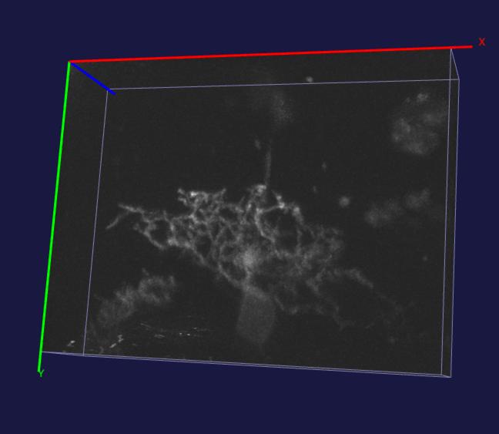

Image Segmentation and convolution

**Denoised**

**Image**

**APP2 tracing APP2 tracing**

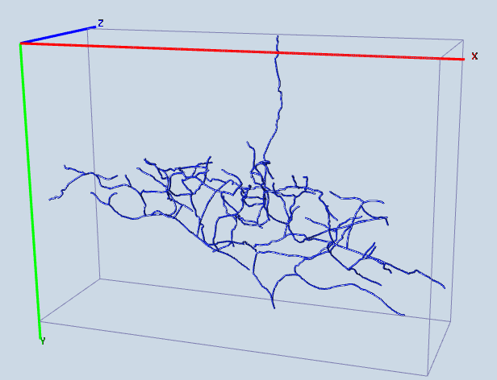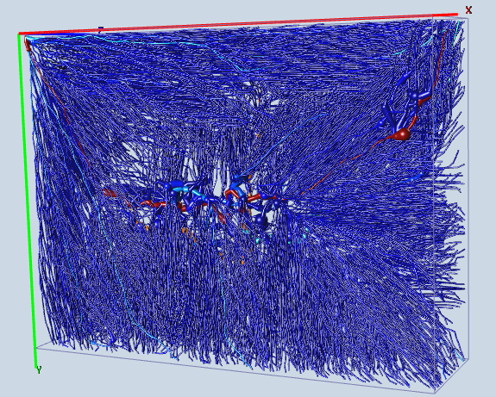

**FIGURE I**

*The accuracy value, which is the ratio of matching traced voxels between the gold trace and the noisy trace, was only 0.03804%. As seen, the low value indicates poor tracing performance on the noisy image*

To remedy this tracing problem, we needed to generate noise free neuronal images to create clean traces like the ones shown on the bottom right. As a first step, Hasan retrieved all of the data that was used from the publicly available gold166 dataset available on BigNeuron. This database contained a collection of .v3dpbd 3D image files along with the coordinates for their ground truth “gold” traces, stored in the .swc file format. First, Hasan converted the .v3dpbd files into the more readily usable .tiff files (using a custom .ijm script in the proprietary ImageJ Fiji Software), stored 20 tiff images into a tiff directory, and then loaded the tiff files from the tiff directory into npy arrays. Second, he converted the .swc files into .txt files (a fairly simple renaming process). The .swc (now .txt) files contained lots of information, including the (x,y,z) coordinate pairings of neuronal voxel locations. Hasan pulled the coordinate data from the .txt files and used them to populate an empty numpy array of the same dimension as the image. Below are 3D visualization of both a raw noisy image as a numpy array (given an arbitrary brightness threshold) as well as its given ground truth:

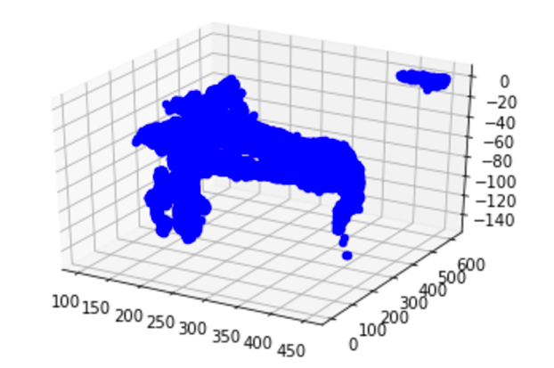 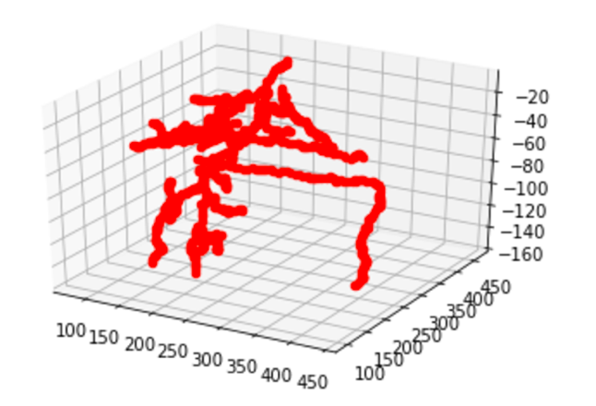

**FIGURE II**

Some challenges we faced with the .swc files was that they also contained a surplus of information regarding the neuronal voxel classification. Oftentimes, the classification was not according to the .swc file standards, since the gold166 dataset was a compendium of images from international labs, some of whom did not follow the .swc file standard. As a result, we modified our project to only classify whether a voxel is ‘neuron’ or ‘not neuron’, rather than classify them as different type of neuron segment (ex. dendrite, axon, soma, etc.)

Crystal found a usable 2D convnet architecture, U-Net (normally used for medical image segmentation) and attempted to implement it to be usable with 3D images. U-Net is a full convolutional neural network which uses skip connections of residual learning and upscaling. Charu launched a P2 Instance on Amazon Web Services to run the project on, because P2 was the best for machine learning and deep-learning. However, AWS charged much more money than what expected to run the GPU, and it went beyond the amazon educate amount. We also tried running our program on the labunix computers, which we were able to SSH into. We were also able to copy over all our code and directories to the lab computers; however, when we ran the *exact same code* (with filepath changes of course) on the labunix computers, we got a plethora of errors. We chalked up some of these errors up to library version issues (some of which we tried updating but were not able to).

So in the end, we had to stick to using a 2D version of U-Net instead, running on our local laptops, thinking that maybe we could just create 2D segmentation masks instead of 3D ones. See figure III for a general layout of the architecture:



**FIGURE III**

To convert to 2D, Hasan and Crystal simply took an arbitrary number of “middle layer” slices from the 3D numpy files, usually at the halfway depth points of the 3D images (we assumed that the half depth mark would contain some neuron segments). Hasan and Crystal then worked on implementing the U-Net architecture and building the model that would learn what voxels of each image are a part of the neuron and what voxels are a part of the background. They used 15 raw .tiff and .txt files as their train and train ground truth data respectively, and used 5 raw .tiff and .txt files as their test and test ground truth data, respectively. After creating, fitting, and making mask predictions with model.predict(), they obtained a list of 64x64 2D masks that theoretically show the image segmentation of a given neuron’s 2D layers. See figure IV for the example mask:

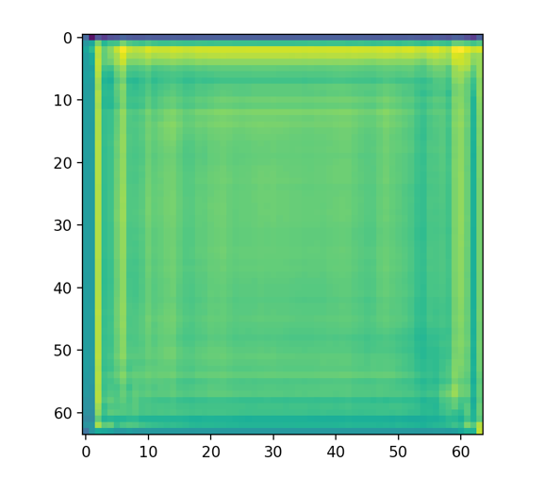

**FIGURE IV**

Meanwhile, Puja and Charu researched and compared using different tracing algorithms. Specifically, Puja and Charu looked at the original research paper to figure out which of the two algorithms (SmartTracing or APP2) should be to traced a theoretically denoised images. Originally SmartTracing seemed like a better idea because many researchers claimed that the SmartTracing algorithm was able to perform better than APP2. APP2 was said to miss tracing in certain areas where the neuron seemed to be extremely thin. When it was time to implement on the neurons from the gold166 data set however, there didn’t seem to be a difference between the outputs of the two algorithms. We ended up choosing APP2 because it’s a built in plugin to Vaa3d (one of the cellular imaging platform we used to visualize the neurons in 3D) rather than SmartTracing, which was a third party plugin that had to be installed and run separately. In order to trace with APP2 for this project, we had to use the Vaa3D GUI and manually run the plugin on an image one at a time.

Even though we did not get fully denoised and segmented neuron images, Puja still ran initial accuracy calculations and compared overtraced noisy images with their respective gold trace counterparts, as shown in Figure 1. The accuracy calculations are presented in the results section.

***Conclusions and Future Work***

For future directions, we hope to use the intended 3D architecture to get the actual 3D segmentation masks we were hoping to obtain. Furthermore, we would love to have more complicated image segmentation processes where neuronal voxels are also categorized by segment type (ex. soma, dendrite, etc.). It would be interesting to use different tracing algorithms other than just APP2, such as SmartTracing, to gain more insight about the performance of these tracers. Also, rather than using the BigNeuron datasets, we would like to test Neurosieve on our own data, such as data from Crystal’s lab.

***References***

U-net 2d architecture from O. Ronneberger, P. Fischer, and T. Brox, “U-net: Convolutional networks for biomedical image segmentation,” in MICCAI, pp. 234–241, Springer, 2015.

U-net 3D architecture from O. Cicek, A. Abdulkadir, S.S. Lienkamp, T. Brox, O. Ronneberger, *3D U- Net: Learning Dense Volumetric Segmentation from Sparse Annotation*, 2016, [online] Available: .